Problem Statement: Create following architecture on AWS

VPC with servers in private subnets and NAT
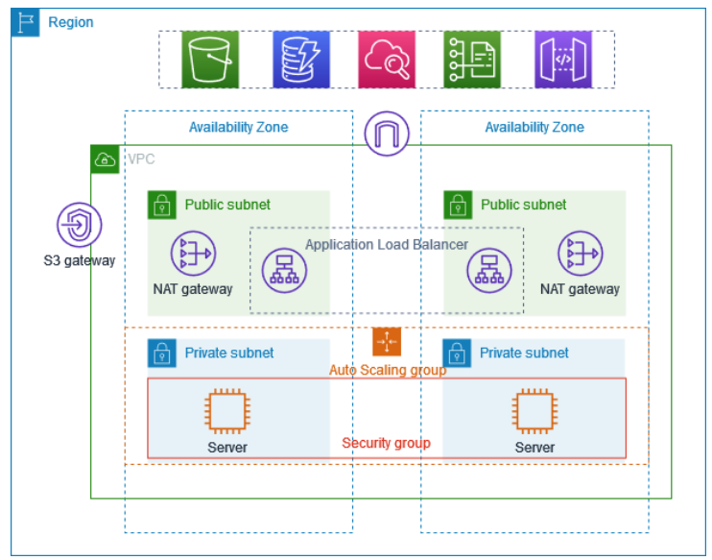
Steps to follow:
To implement above architecture in AWS please follow following steps
- Create a VPC, Subnets, Route Tables, NAT Gateway and Internet Gateway
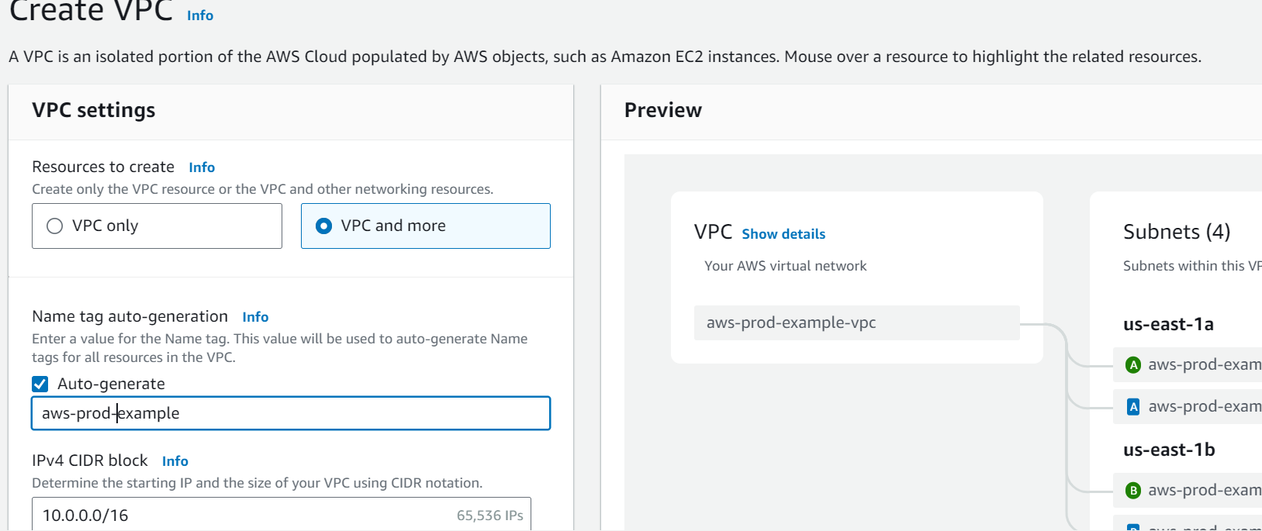

- Select Number of Availability Zones as 2, Number of public subnets as 2, Number of private subnets as 2, NAT gateways as 1 per AZ and click on ‘Create’
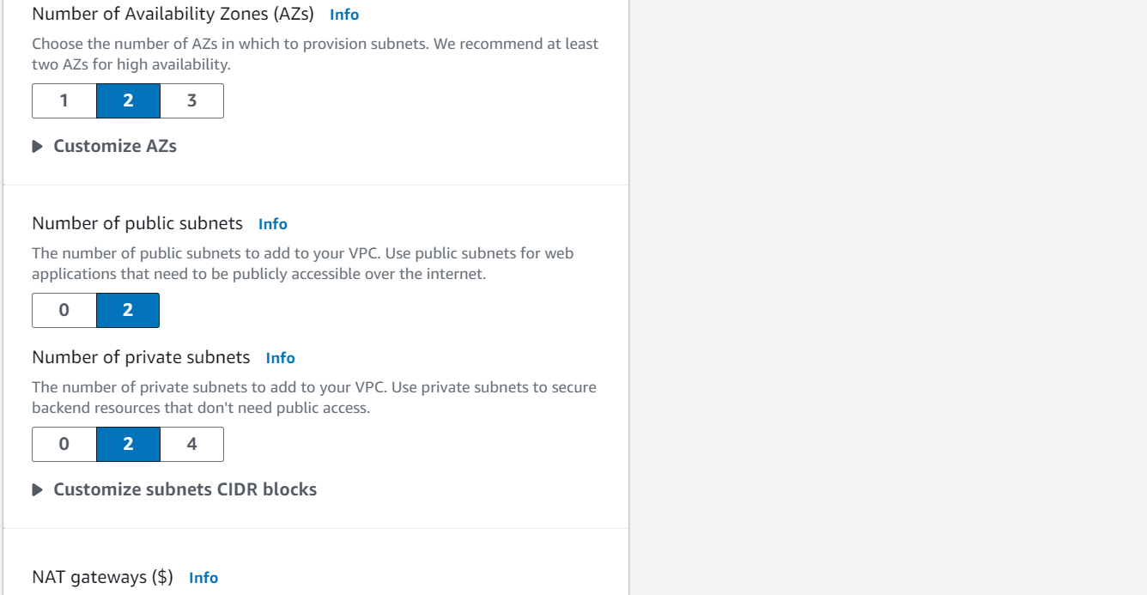

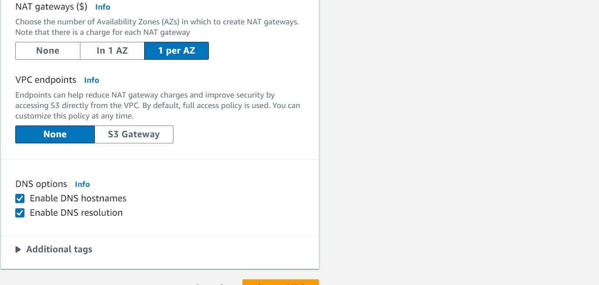

- All components are created automatically
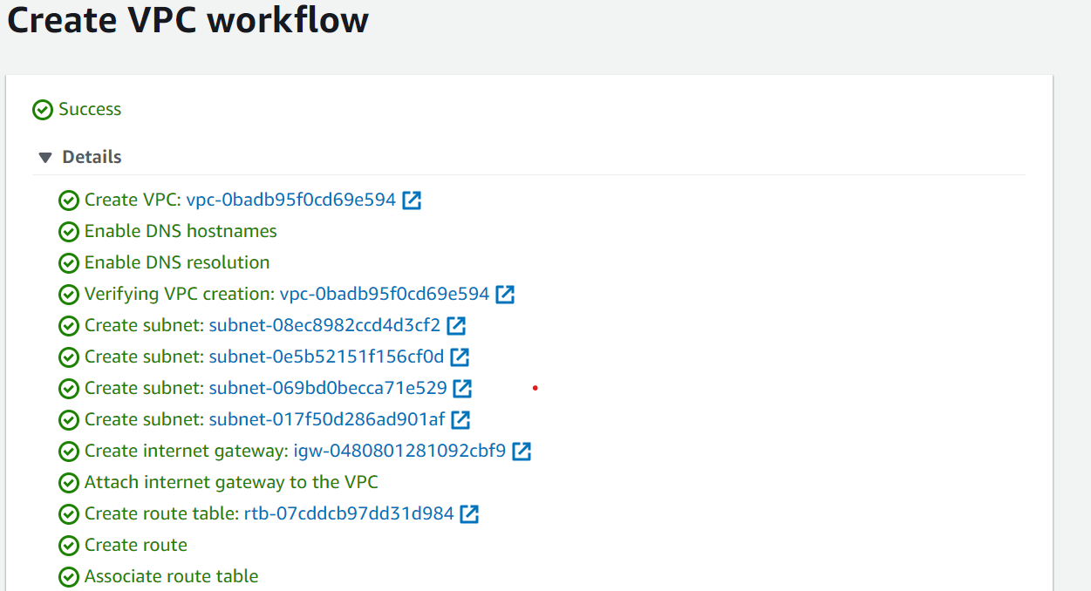

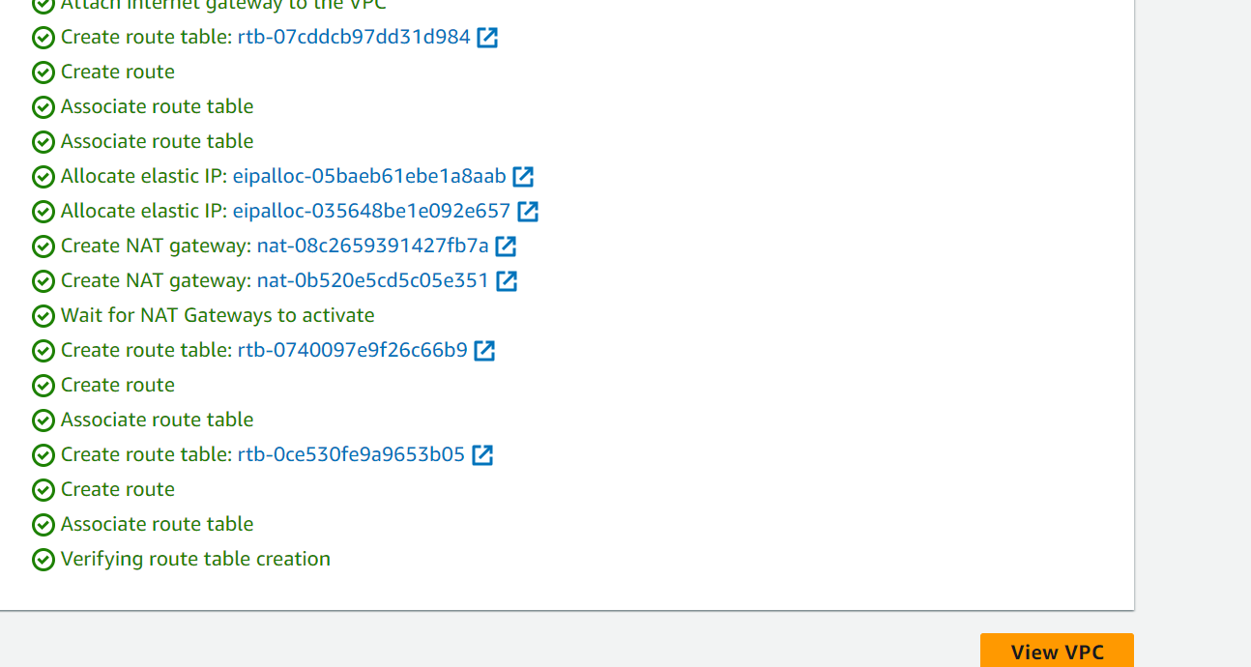

- Create Auto Scaling Groups for EC2.For that first create a Launch Template
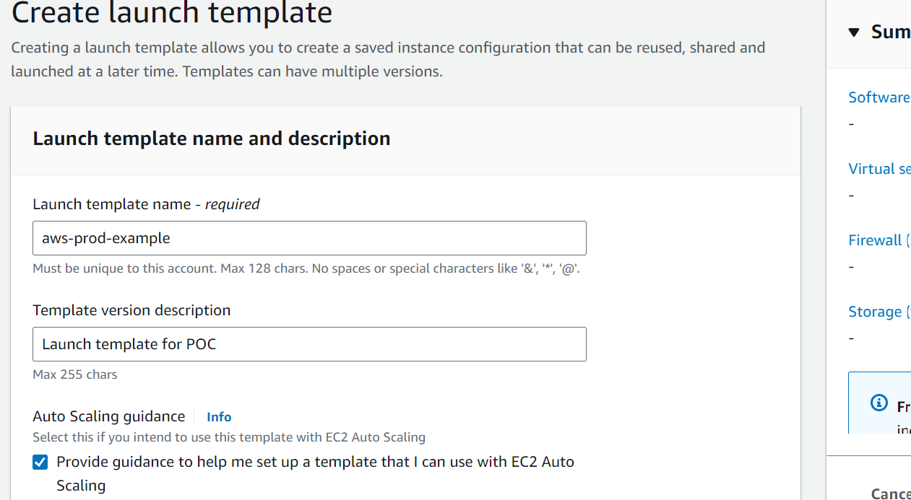
- Select Amazon Machine Image. I selected Ubuntu Server 24.04 LTS (HVM), SSD Volume Type (ami-04b70fa74e45c3917)

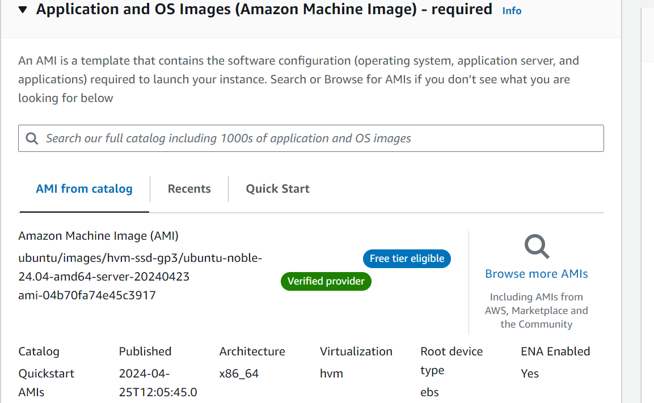

- Select Free tier Instance type and Key Pair
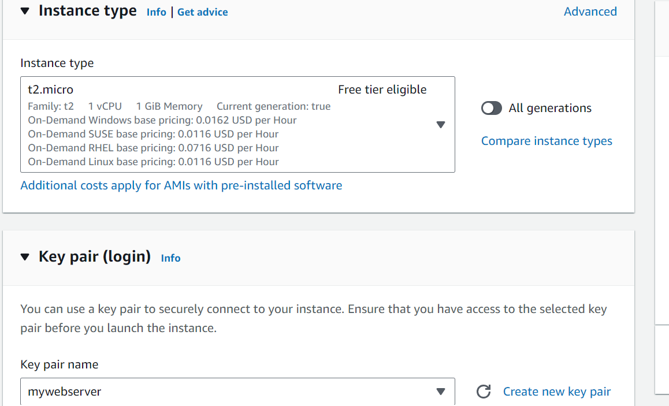
- Select VPC. Configure Security group and Inbound Security Group Rules. Port 22 has been added to allow SSH from anywhere. Port 8000 has been added to access Python based application which will be deployed. You can configure the rules depending on which ports you want to access the deployed application. Once done click on ‘Create Launch template’.
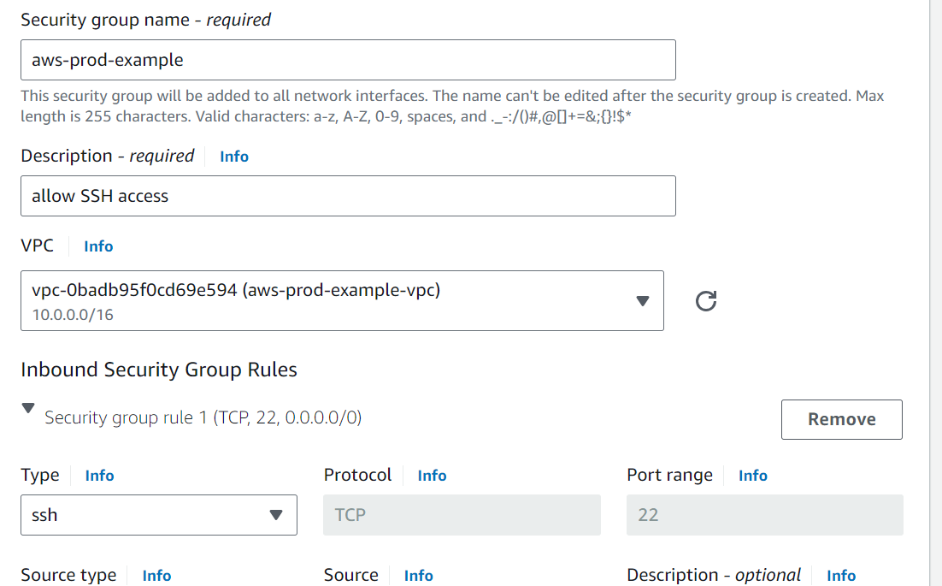

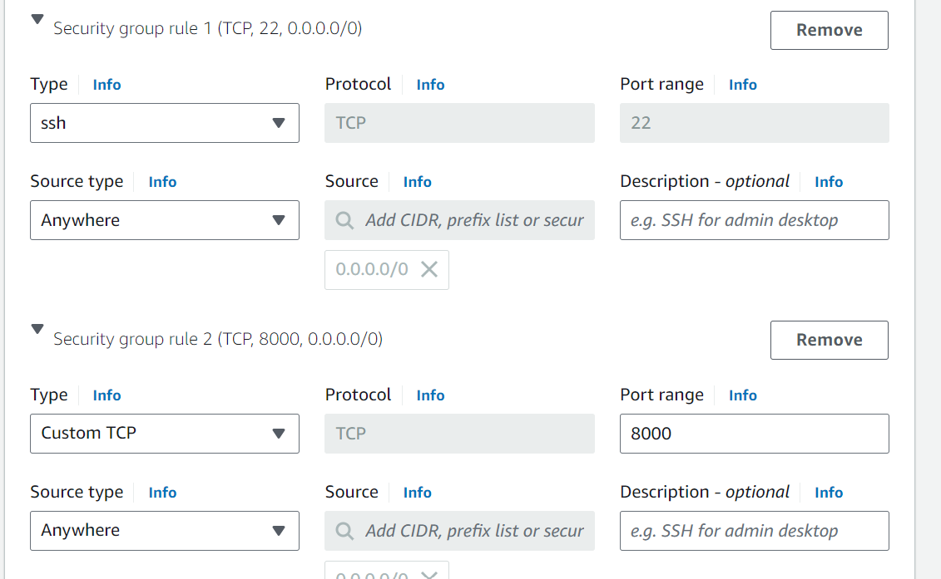
- Launch template has been created
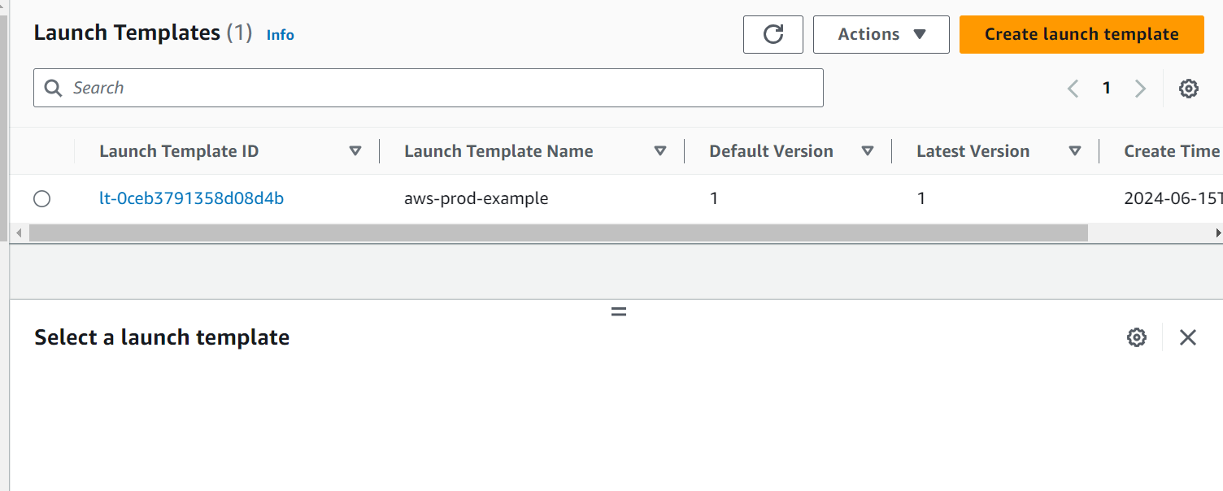

- Create Auto Scaling group. Select the Launch template which was created before
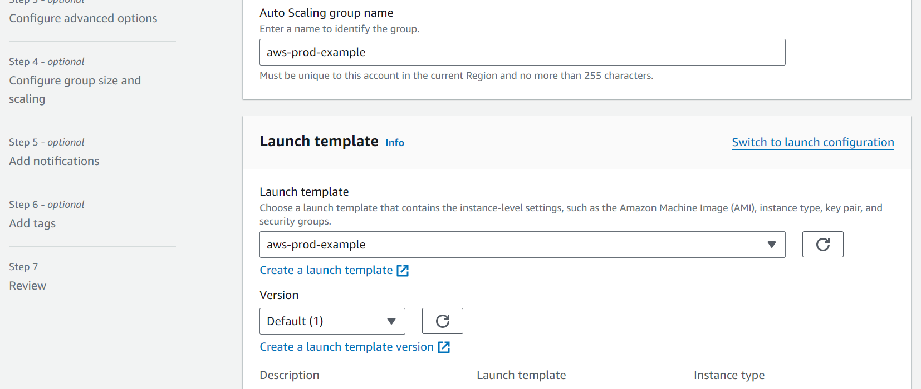

- Select VPC, Availability Zones and subnets where you want the EC2s to be available.
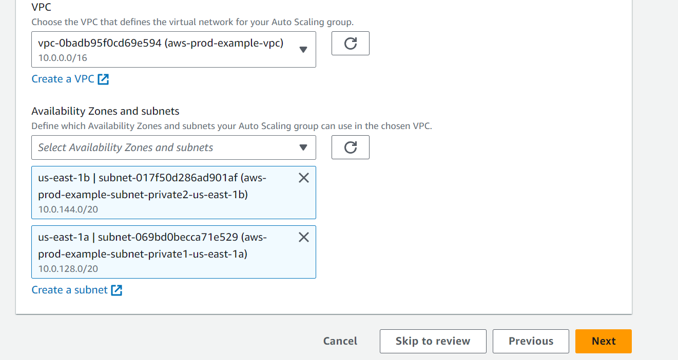

- Do not attach Auto Scaling group to any Load Balancer. Select No load balancer
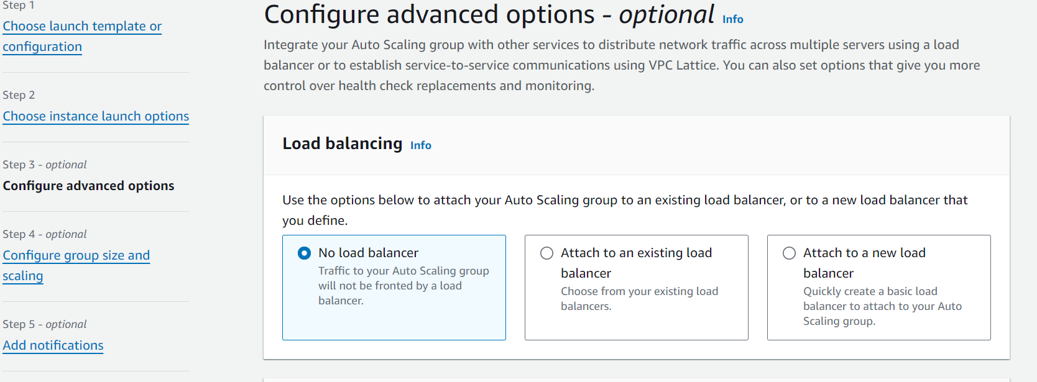

- Configure Desired, Min and Max capacity. Select ‘No Scaling policies’
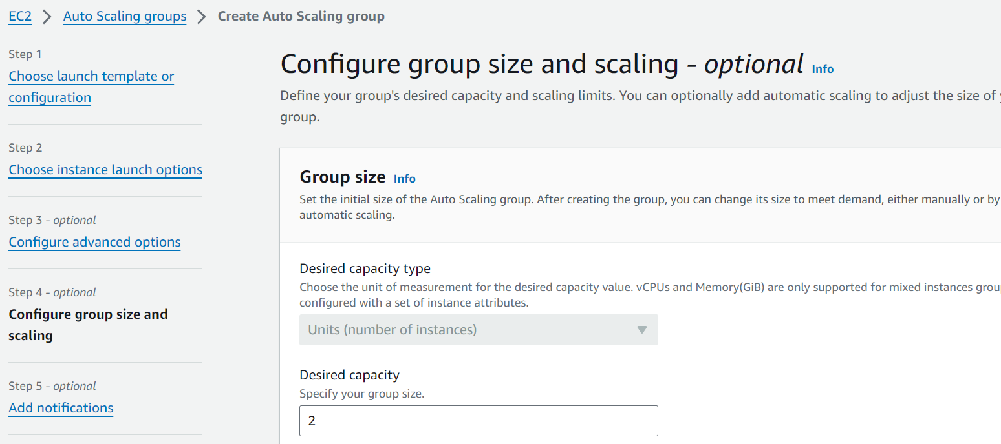
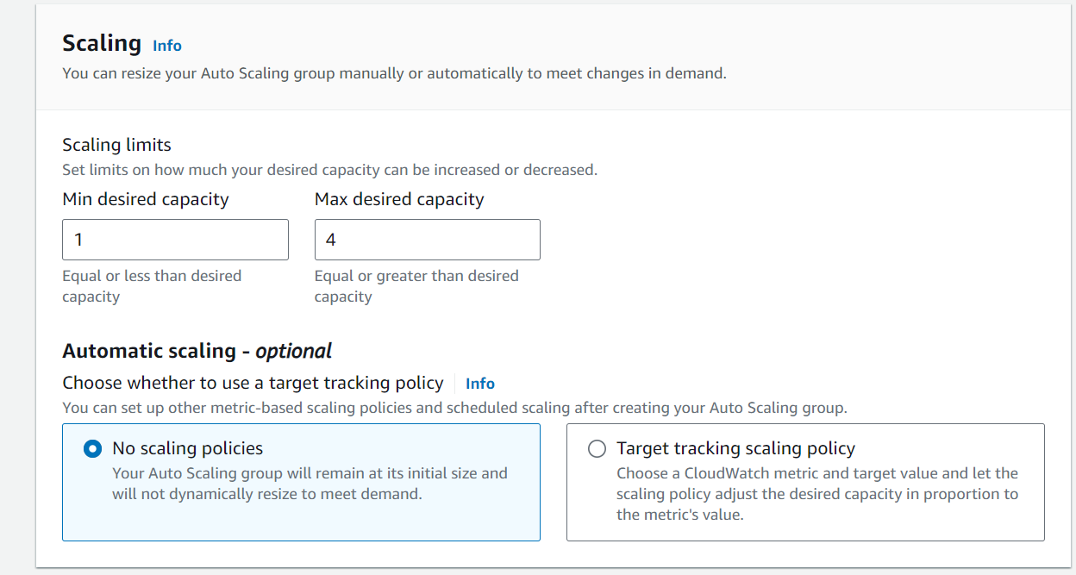

- Skip Add notifications
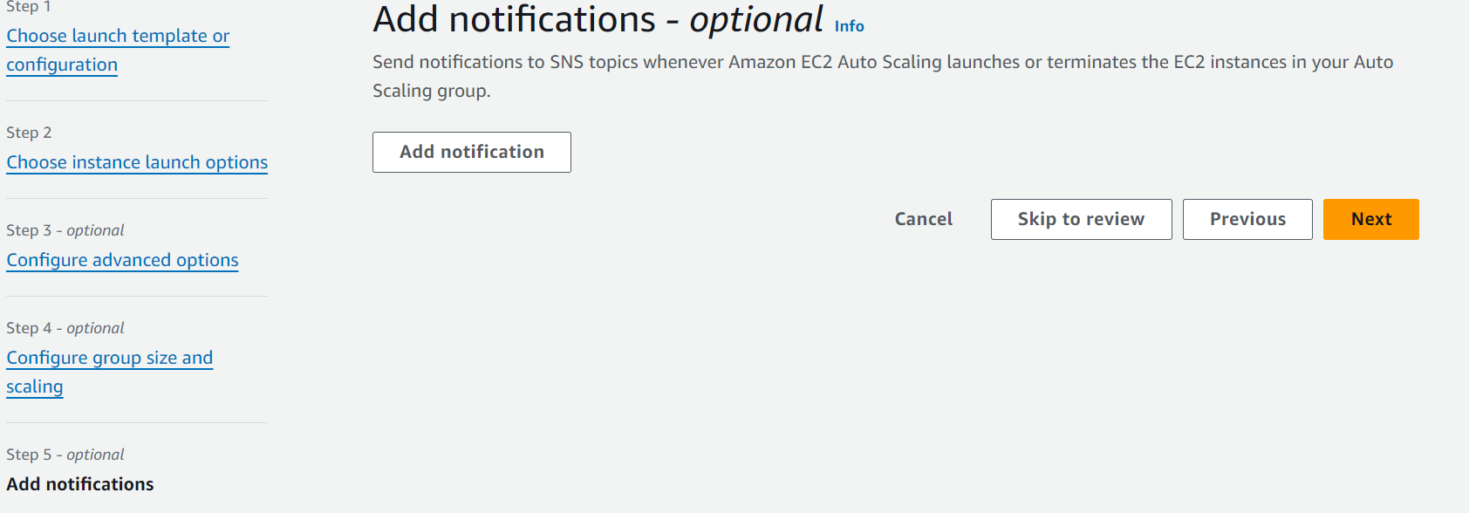

- Skip Add tags

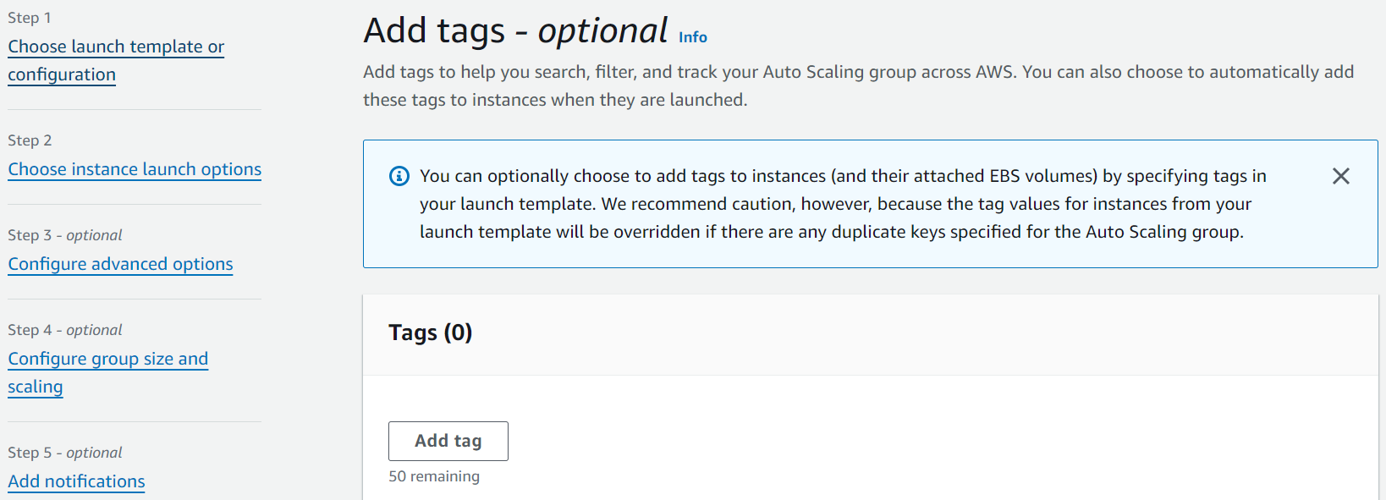

- Create Auto Scaling group
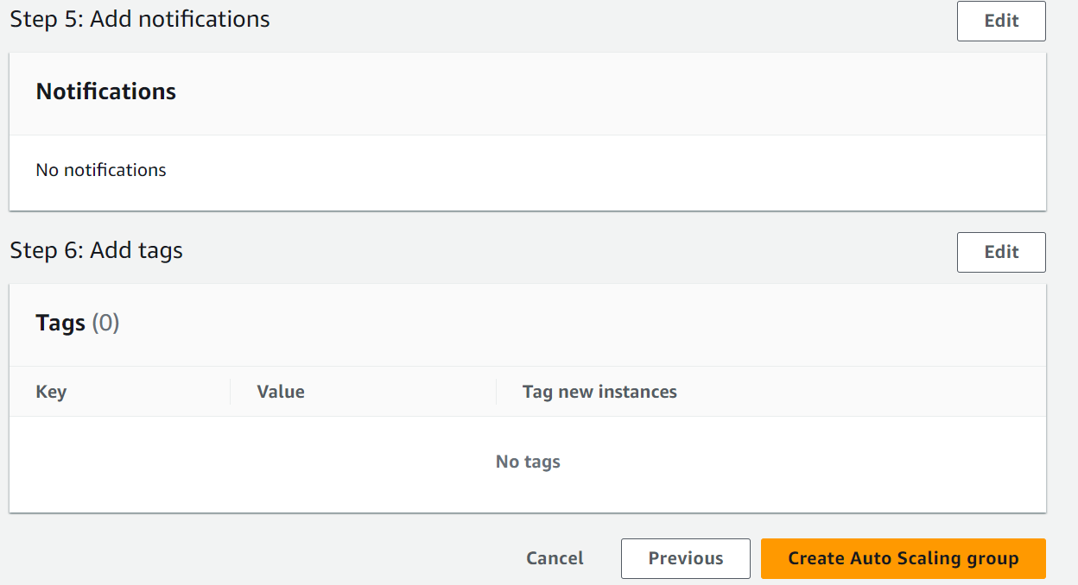

- Instances have been created because of Auto Scaling Group. These instances have been created in separate AZs and in private subnets because while creating ASG we selected two AZs. Check screenshot 10.

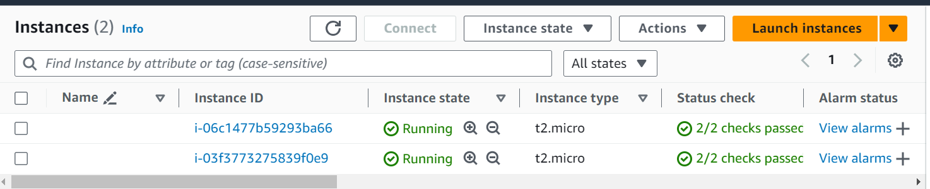

- These instances do not have public IP addresses hence to login to these instances and install an application we have to create a Bastion host

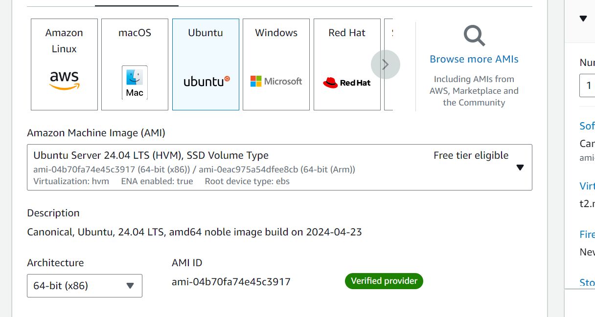
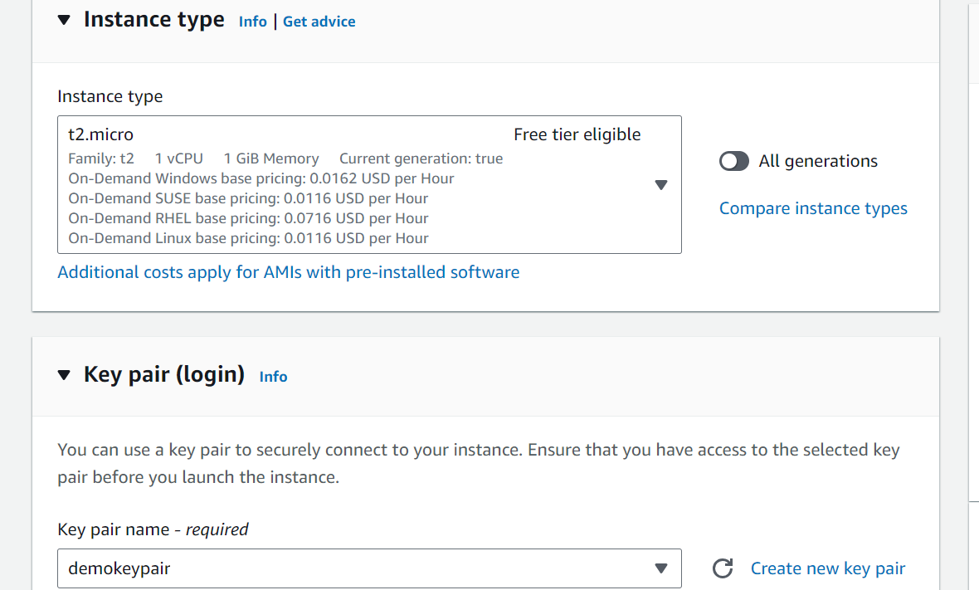
- Select the same VPC in which the other EC2 instances are located
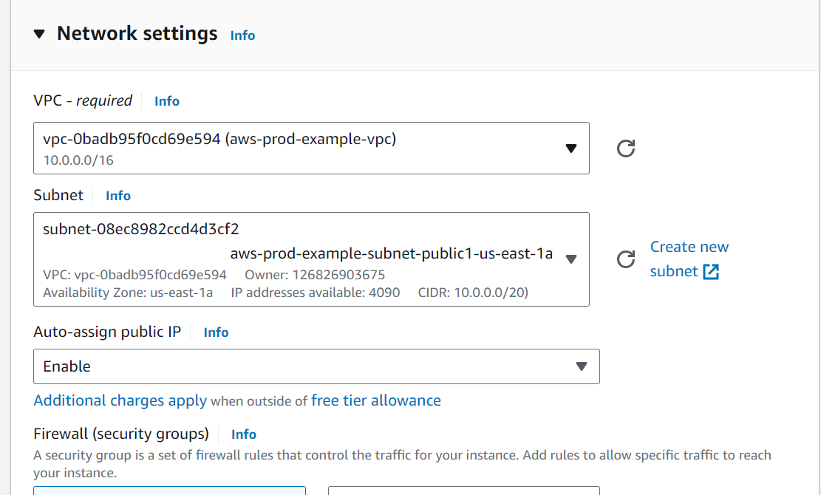

- Add SSH in the security group of Bastion Host to ssh to Bastion Host. Through Bastion Host you can SSH to EC2 in the private subnets

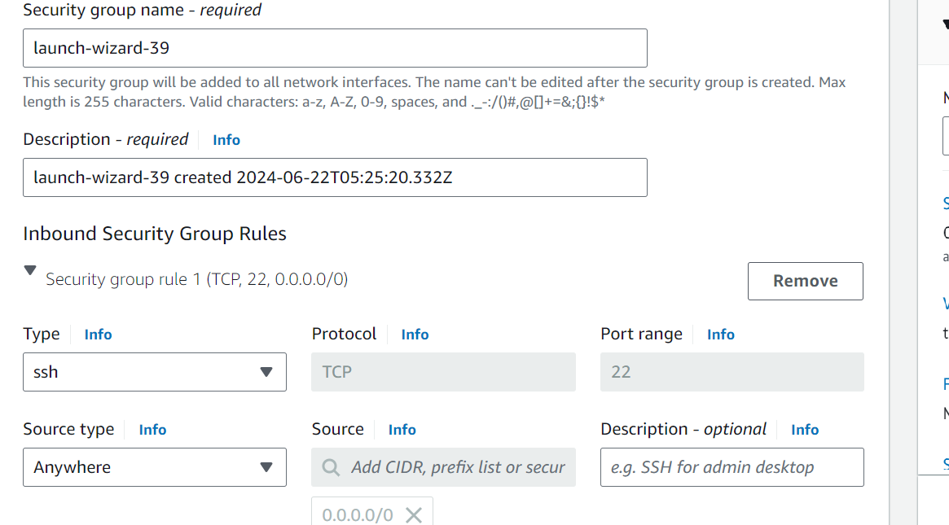

- SSH into the Bastion Host
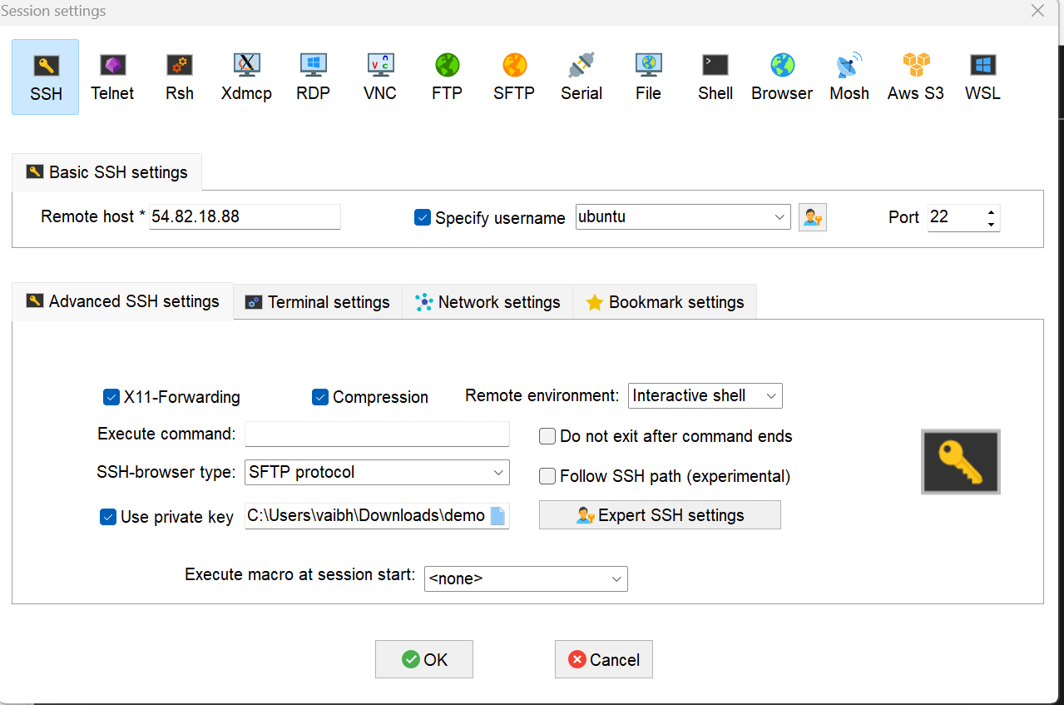

- Connection has been established in the Bastion Host
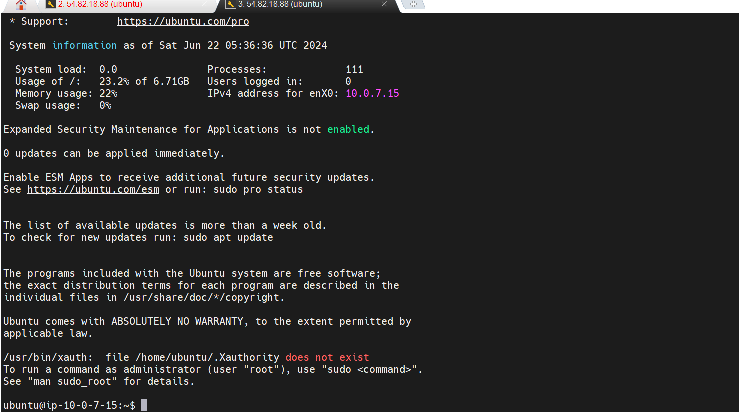

- To SSH into the EC2 instances in private subnets, upload the keypair in the Bastion host
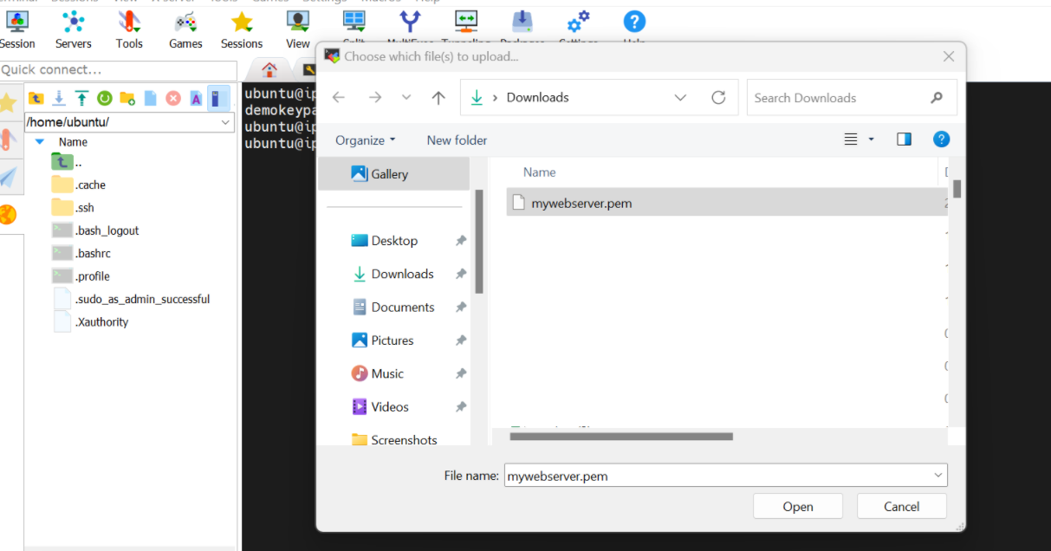

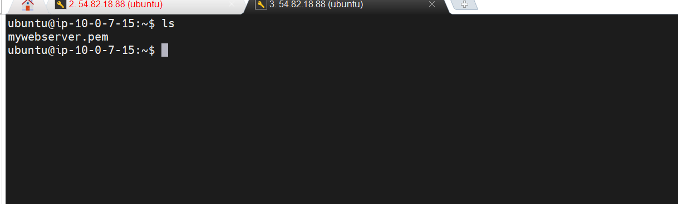

- SSH into the private EC2 instance using the pem file through the Bastion Host. Provide read and write permission of pem file to the user by using chmod 600 command

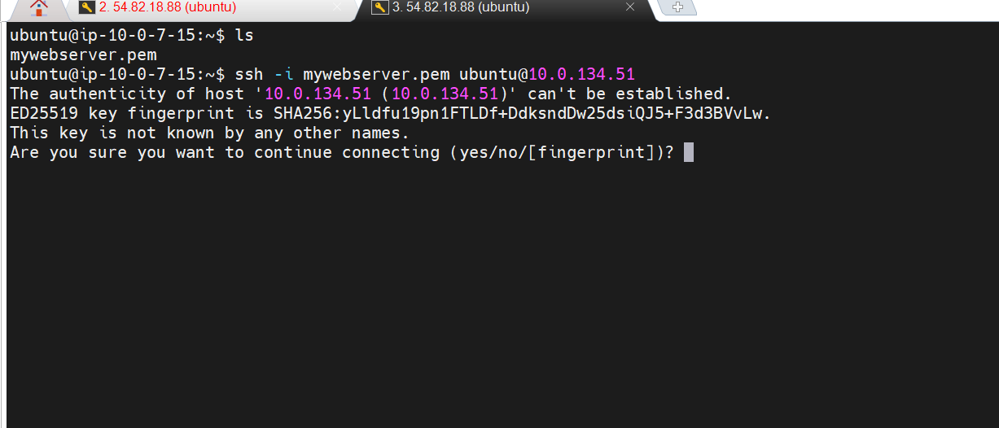
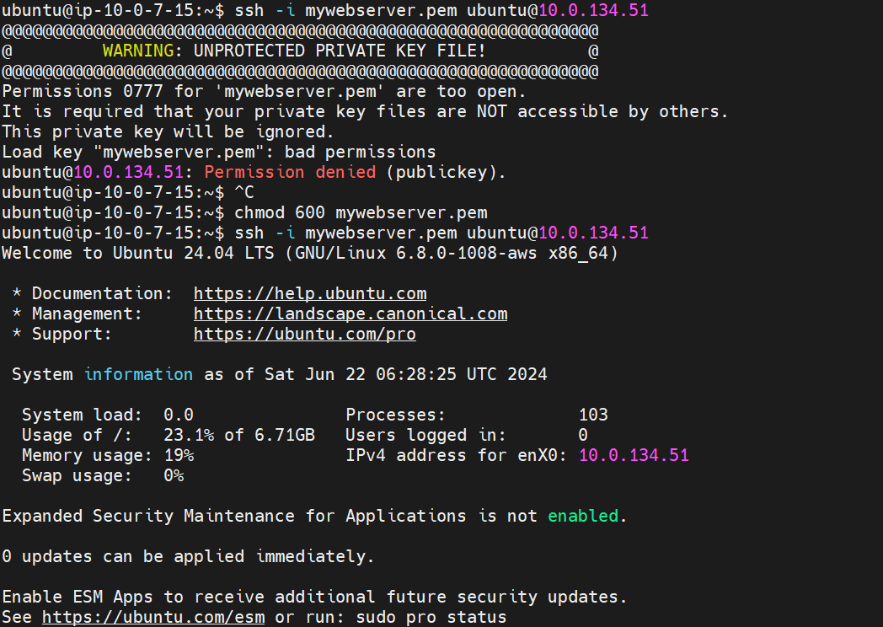

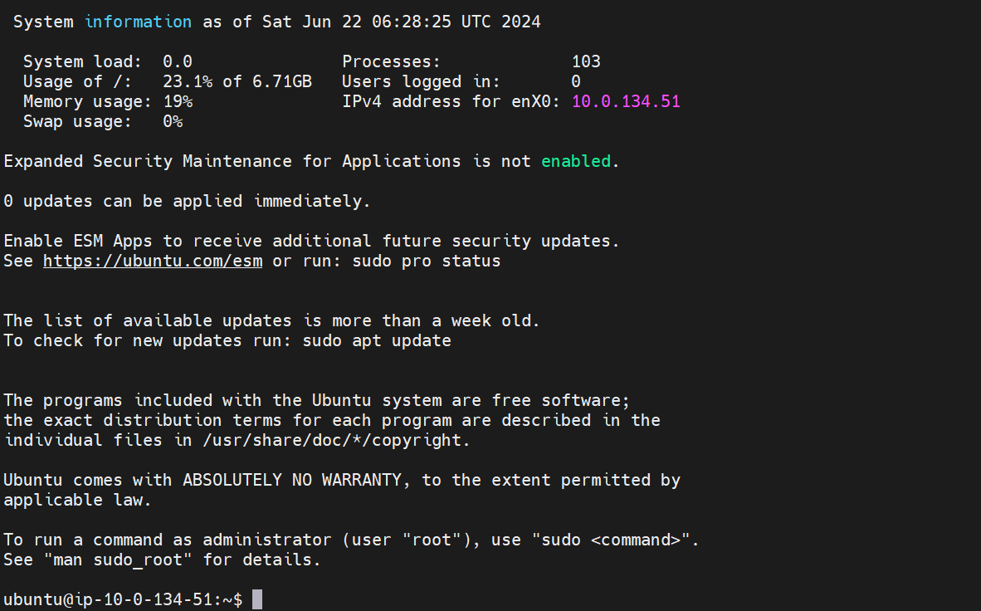

- Create an html page and run a python server on port 8000
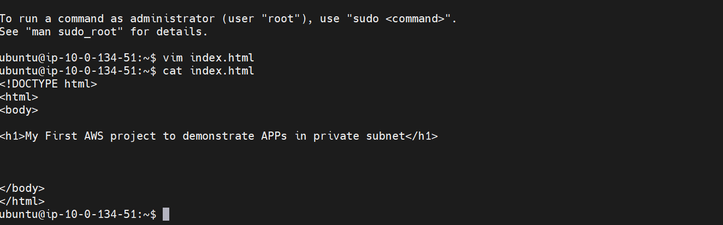

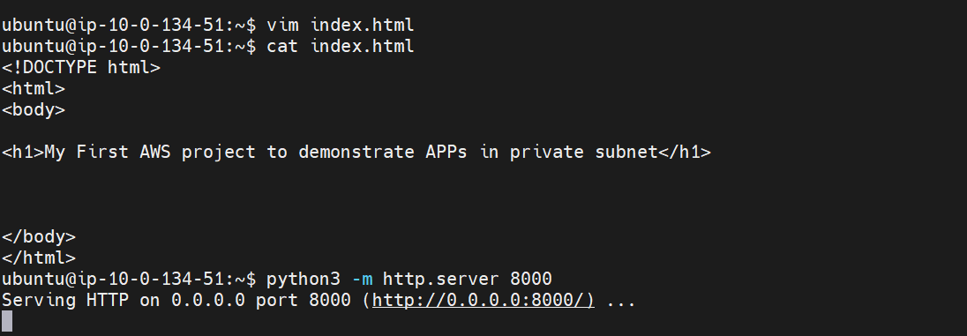

- Create Load Balancer in the same VPC. Select the two AZs and select public subnets. Select the security group
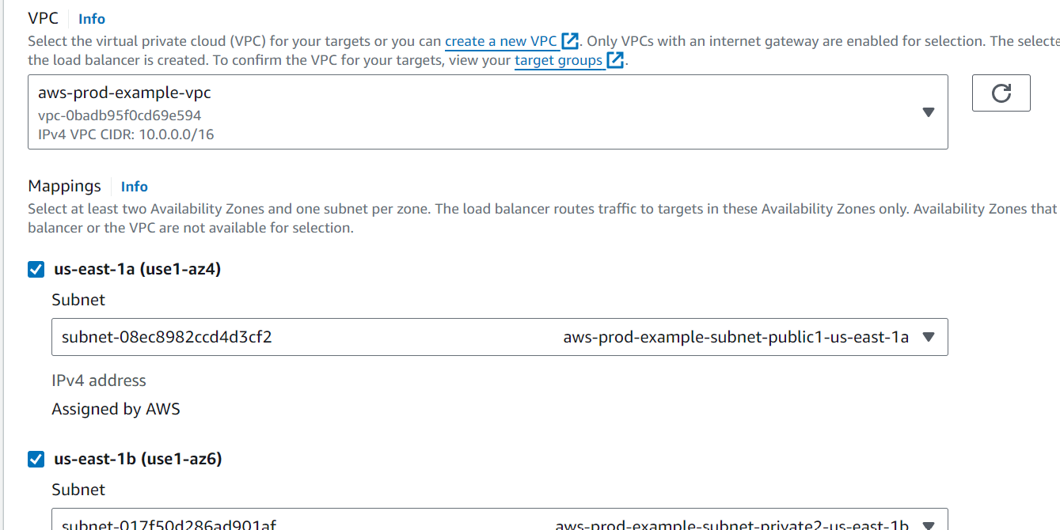

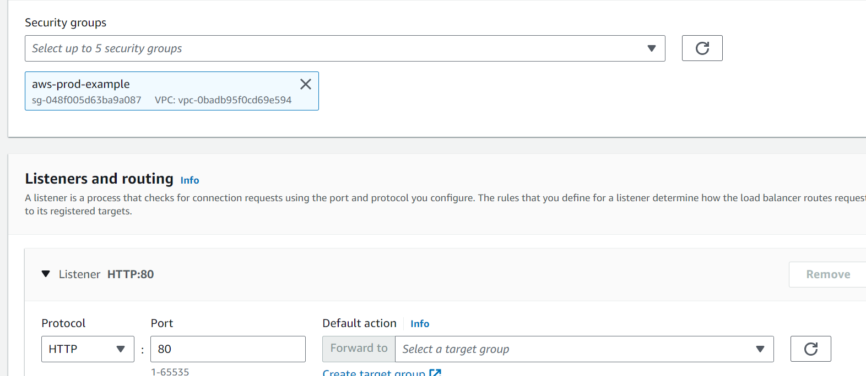

- Create a Target group to access EC2 instances via the Load Balancer. Register Targets as the two EC2 instances in the private subnets
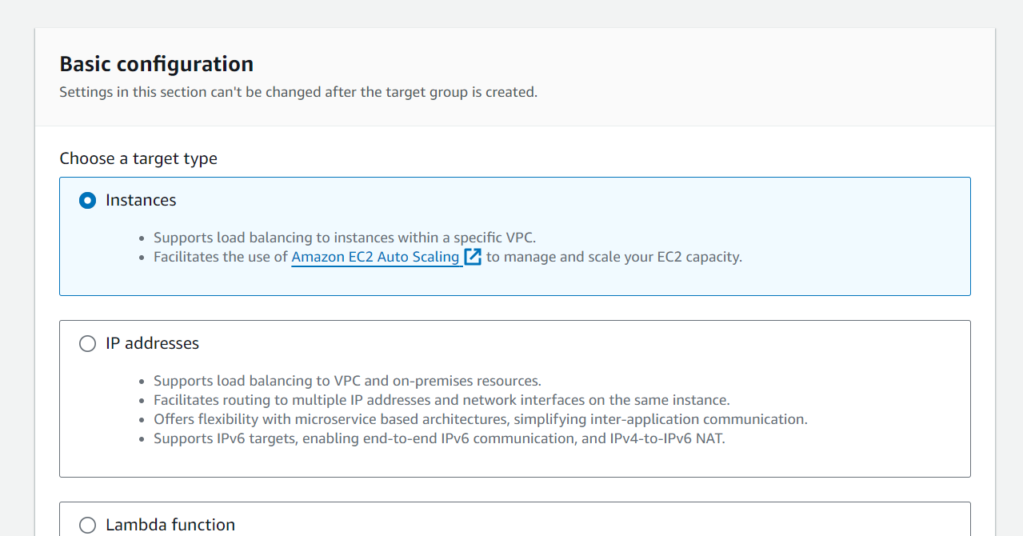

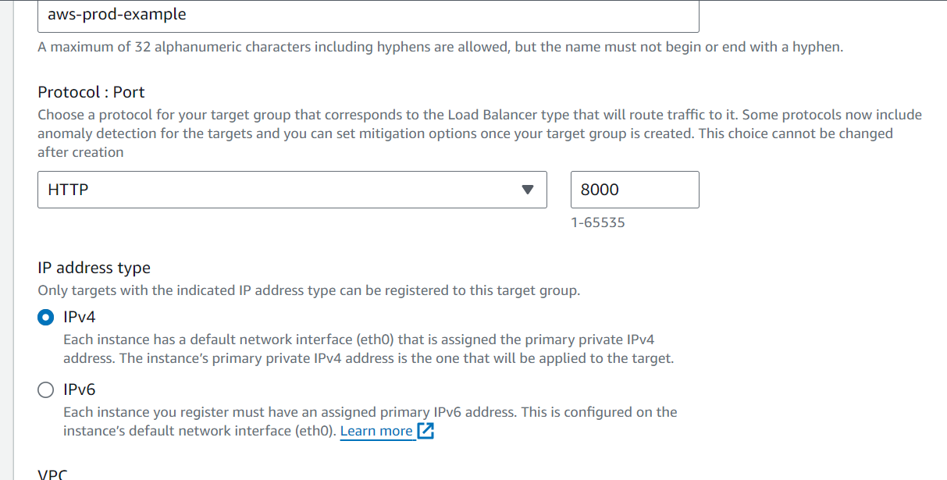

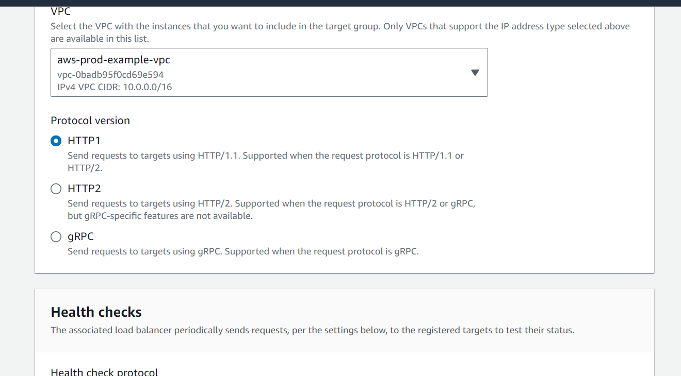
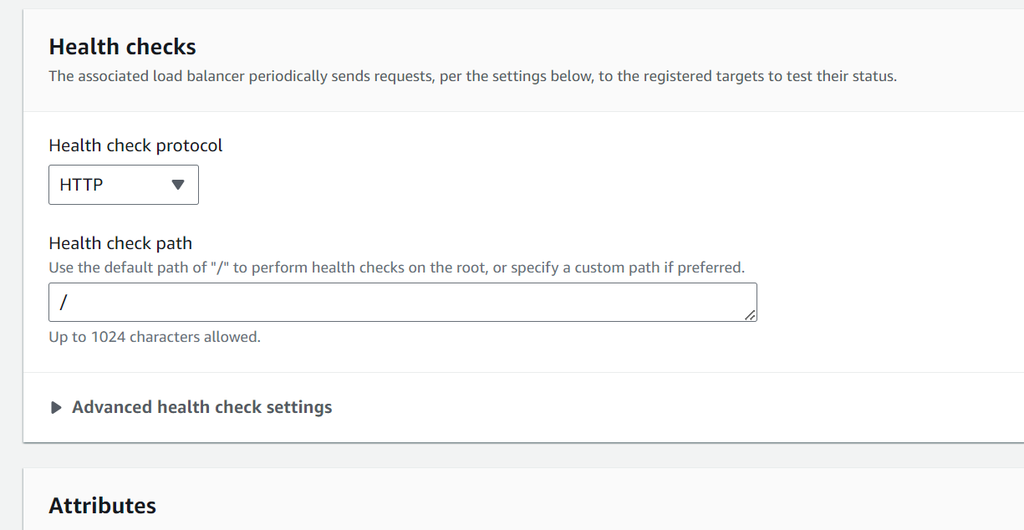
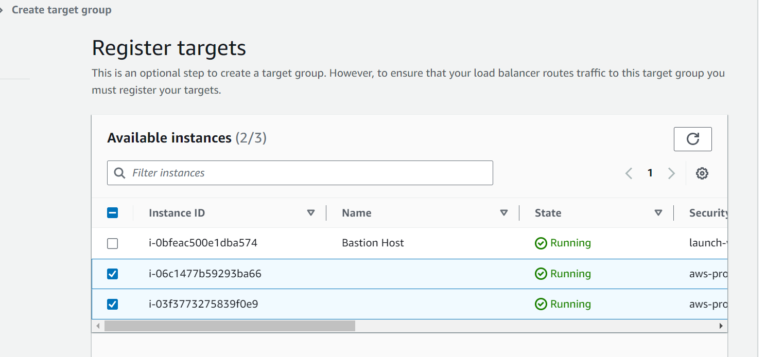
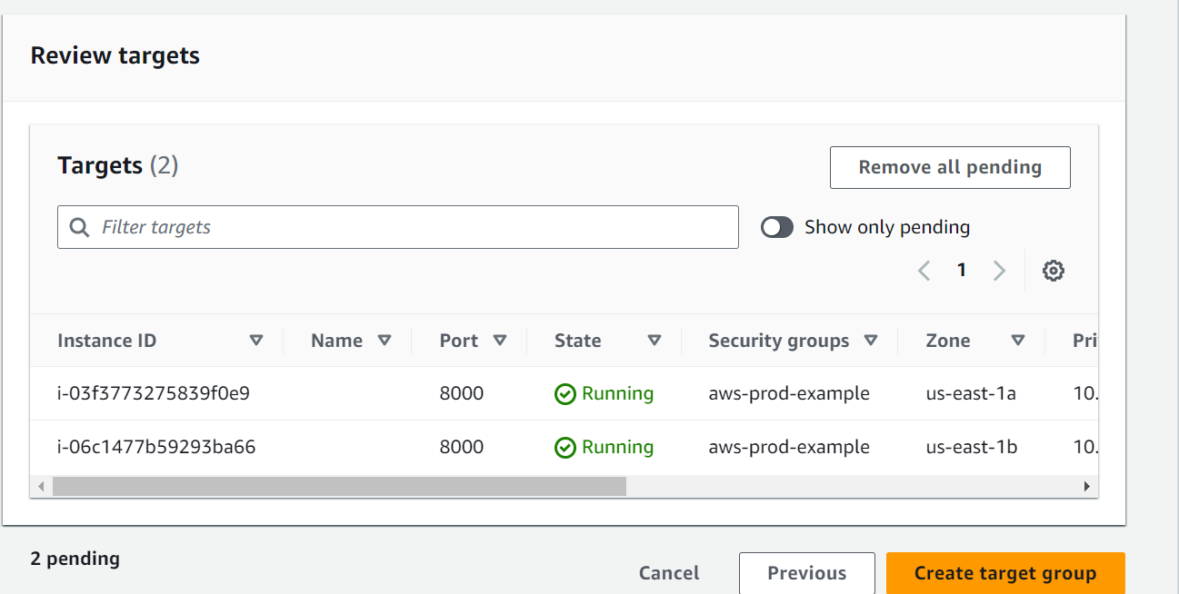
- Select the Target group in the Load Balancer
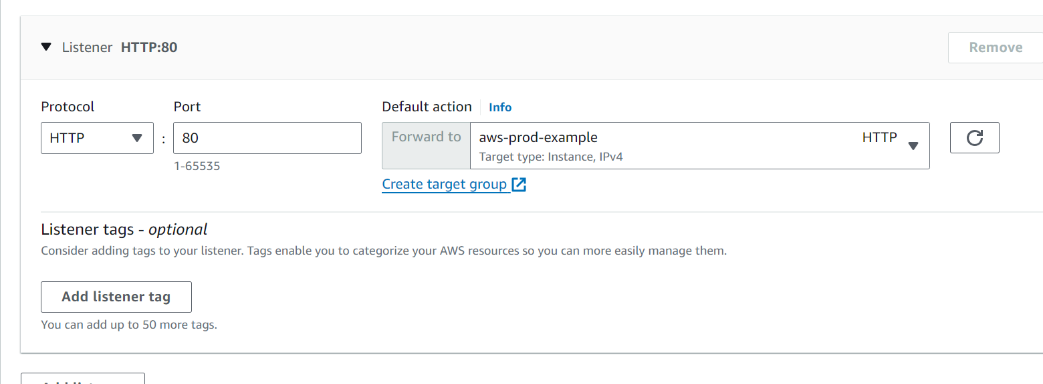
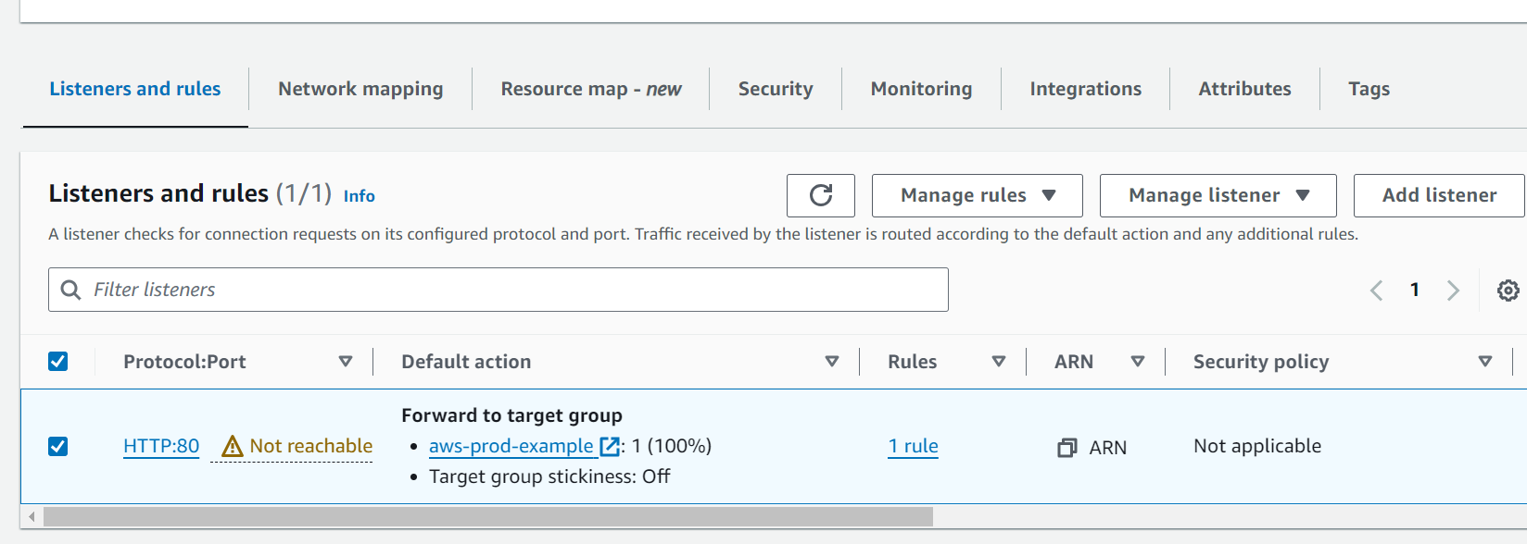

- The target group is not reachable because the security group of Load Balancer has not allowed http traffic on port 80. Open the security group and allow http traffic on port 80

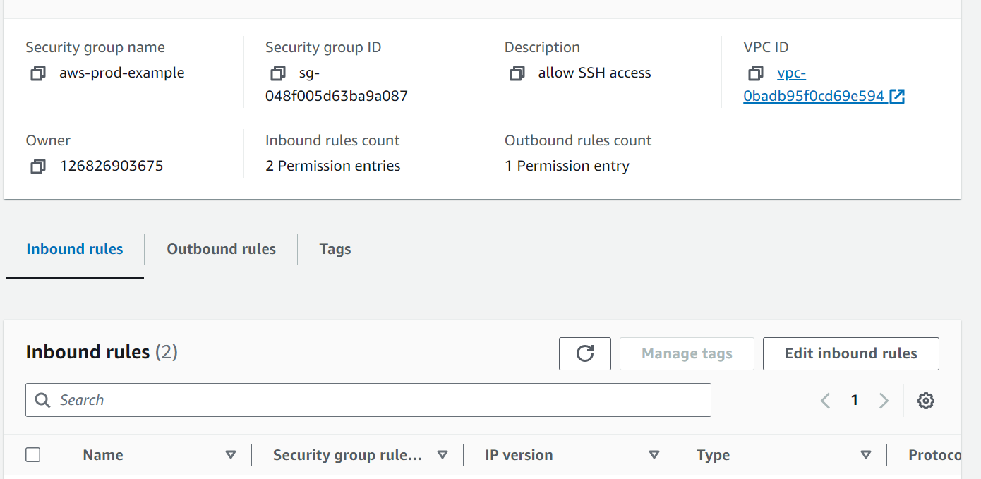
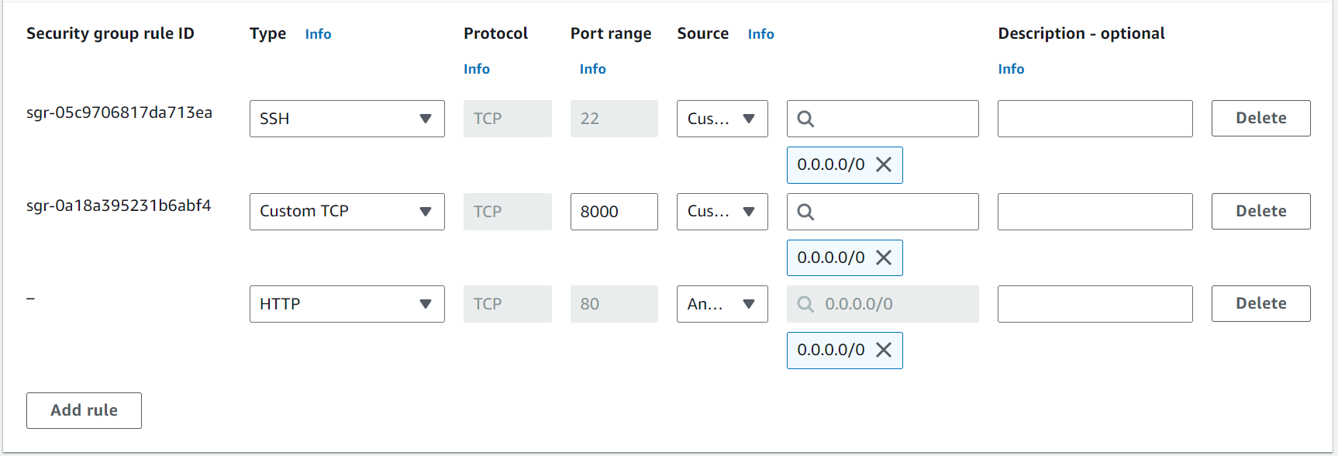

- The Target group is reachable now
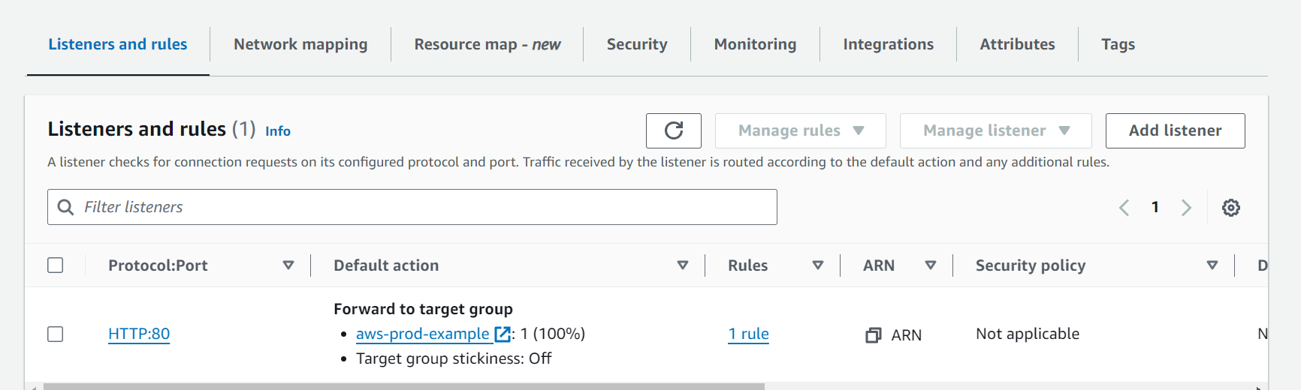
- SSH into the second private EC2 instance using the pem file through the Bastion Host and create index.html and start the python server
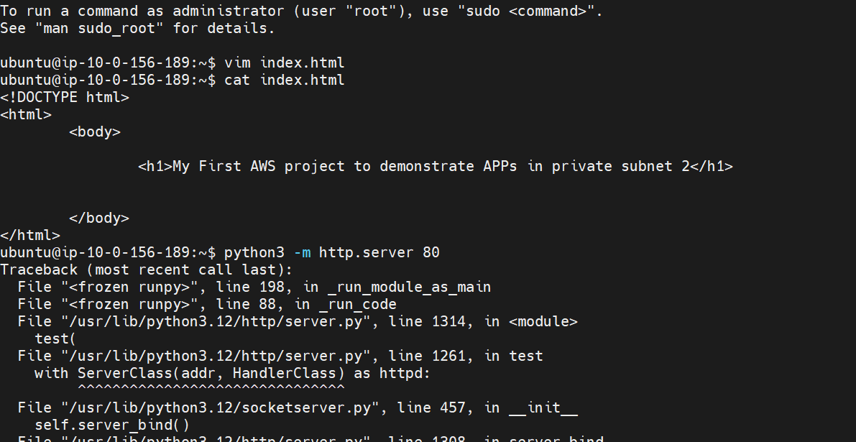
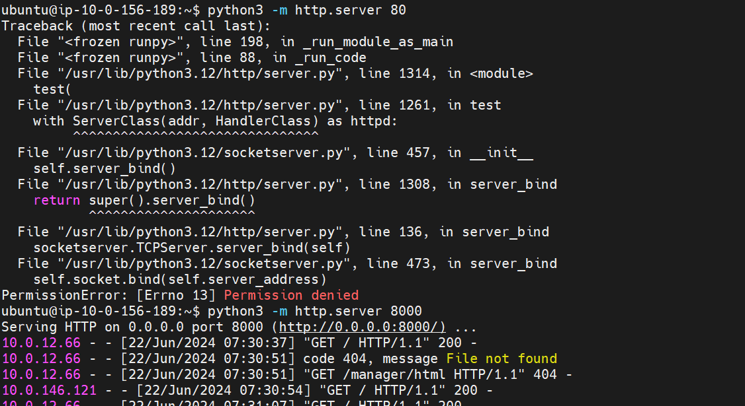

- Copy the DNS name of the Load Balancer and paste it in the browser to see if the servers are reachable. You can see both the EC2 instances are reachable and the load balancer is working by sending the traffic on the two EC2 instances
